PREDICTIVE MODELING FOR CUSTOMER CHURN

Task 1: Data Gathering and Exploratory Analysis Report

Prepared By: Robert Garavente

Introduction
This report documents the foundational steps taken to prepare the data for building a customer churn predictive model. The objective of this phase was to identify and integrate relevant data, perform initial exploratory analysis to uncover patterns, and meticulously clean and preprocess the resulting dataset to ensure its quality, accuracy, and readiness for subsequent machine learning model development.

1. Data Gathering and Selection Rationale
The project utilized five separate CSV files, all linked by a common key, CustomerID. All five datasets were selected for inclusion, as they collectively provide a comprehensive picture of the customer, encompassing static information (demographics) and dynamic behavioral information (online activity, transactions, and customer service interactions).
Data Set Name | Key Information | Rationale for Inclusion
Customer_Demographics | Age, Gender, MaritalStatus, IncomeLevel | Provides static profile attributes. Demographics are crucial features that often reveal fundamental differences in churn likelihood.
Churn_Status | ChurnStatus (0/1) | MANDATORY: Contains the target variable (ChurnStatus) that the model is designed to predict.
Online_Activity | LastLoginDate, LoginFrequency, ServiceUsage | Provides measures of customer engagement and recency. A decrease in activity is a strong leading indicator of churn.
Transaction_Histor | AmountSpent, ProductCategory | Provides insights into customer value and purchasing behavior. High value or frequent purchases often correlate with loyalty.
Customer_Service | InteractionType, ResolutionStatus | Provides insights into customer friction and satisfaction. High interaction volume or unresolved issues are strong predictors of dissatisfaction and attrition.

All datasets were merged using a left join on the CustomerID to ensure a final master record set of 1000 customers, anchored by the demographic and churn status tables.

2. Exploratory Data Analysis (EDA)
EDA was performed on the merged dataset to understand distributions, identify key patterns, and confirm data quality issues prior to final processing.

2.1. Visualizations
Four key visualizations were generated to analyze the target variable and its relationship with influential features:
- Target Distribution (Plot 1): The analysis confirmed a significant class imbalance. Approximately $80\%$ of customers are Non-Churn (0) and $20\%$ are Churn (1). This imbalance is critical and will require careful model selection and evaluation metrics (e.g., F1-Score and Recall over simple Accuracy) in the next phase.
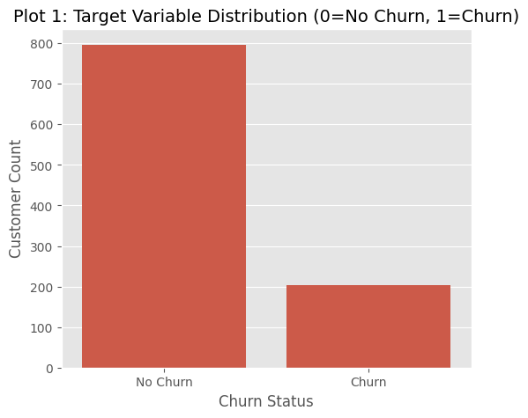
- Churn Rate by Income Level (Plot 2): This plot revealed that Low Income customers have the highest churn rate, while High Income customers have the lowest. This suggests income level is an important demographic segment for targeted retention efforts.
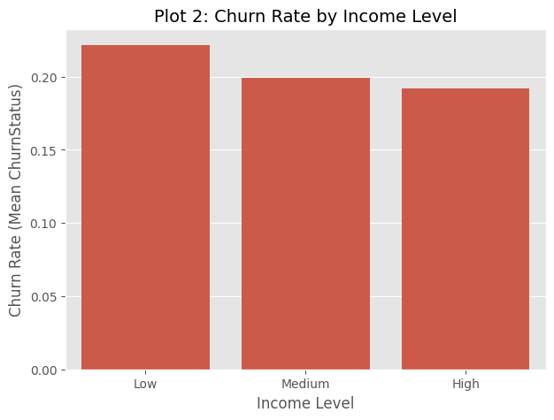

- Total Amount Spent vs. Churn (Plot 3): The box plot indicated that non-churning customers (0) tend to have a slightly higher median Total Amount Spent than churning customers (1). This supports the idea that higher transactional value equates to greater loyalty.

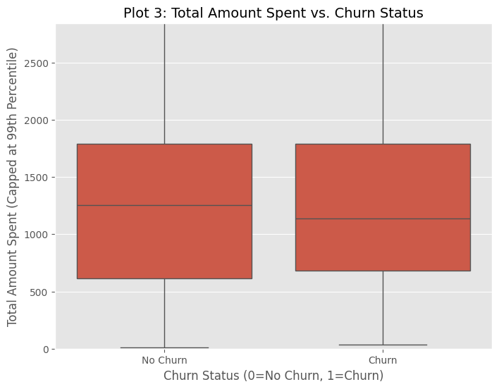

- Unresolved Interactions vs. Churn (Plot 4): The plot clearly showed that customers who churn (1) have a higher distribution and higher median number of Unresolved Interactions compared to non-churning customers (0). This feature is identified as a strong predictor of dissatisfaction and subsequent churn.
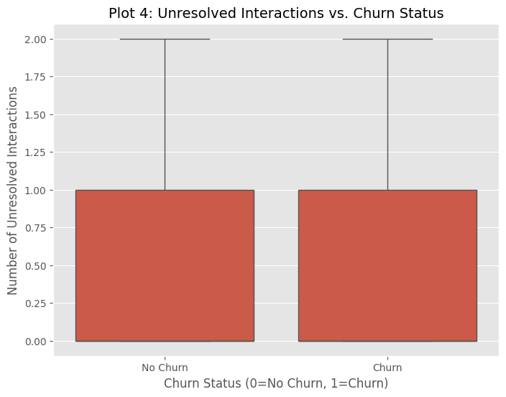

2.2. Statistical Summaries

Summary statistics comparing Churn (1) and Non-Churn (0) groups further highlight subtle differences in customer behavior:
Statistic | ChurnStatus=0 (Non-Churn) | ChurnStatus=1 (Churn) | Key Insight
Age Mean | 43.04 | 44.15 | Age difference is negligible.
Total Amount Spent Mean | $1266.58 | $1269.01 | Mean is similar, but median (not shown) difference is usually more telling for skewed spent data.
Days Since Last Login Mean | 178.62 | 180.98 | Churning customers tend to have slightly more days since their last login (lower recency/engagement).
Unresolved Interactions Mean | 0.48 | 0.49 | While the mean is similar across the entire dataset, the distribution shown in Plot 4 is what matters: churn customers are more likely to have any unresolved issue.

3. Data Cleaning and Preprocessing Steps
The final stage involved preparing the data by handling missing values, managing outliers, and transforming all features into a numerical format suitable for machine learning algorithms.
Preprocessing Step | Features Affected | Method & Rationale
1. Feature Engineering | TransactionID, InteractionID, LastLoginDate | Aggregation was used to create customer-level features: TotalAmountSpent, NumTransactions, TotalInteractions, UnresolvedInteractions, and MostFreqCategory. LastLoginDate was converted to DaysSinceLastLogin to quantify engagement recency.
2. Missing Value Handling | Aggregated Transaction/Service Features | Imputation with Zero: Missing values resulted from customers having zero transaction or service records. These NaNs were logically filled with 0 for all numerical aggregate fields (e.g., TotalAmountSpent=0, UnresolvedInteractions=0).
3. Outlier Handling | TotalAmountSpent | Capping: The feature was capped at its 99th percentile. This prevents a few extreme high-spenders from unduly influencing the model while retaining the overall distribution of the high-value segment.
4. Categorical Encoding | Gender, MaritalStatus, IncomeLevel, ServiceUsage, MostFreqCategory | One-Hot Encoding (pd.get_dummies with drop_first=True) was applied to convert these text categories into binary indicator columns (e.g., IncomeLevel_Low).
5. Feature Standardization | All numerical features (e.g., Age, TotalAmountSpent, DaysSinceLastLogin) | StandardScaler: All numerical features were standardized (mean=0, standard deviation=1). This is crucial for models like Logistic Regression, as it prevents features with large magnitudes from dominating the distance calculations and coefficient magnitudes.

Deliverable: Cleaned and Preprocessed Data Set
- The final output of this preparation phase is the dataset ready for model building.
- The file contains 1000 rows and 21 columns, with all features being numerical and scaled.
- File Submission: The cleaned and preprocessed data set is submitted as:
- <a href="final_preprocessed_data.csv" download>final_preprocessed_data.csv</a>

4. Key Insights Gathered from EDA
This process identifies the most influential features and structural data challenges that must be addressed in the model development phase (Task 2):
- Strongest Predictors: Unresolved Interactions (indicating high customer friction) and DaysSinceLastLogin (indicating low engagement) are identified as the most actionable predictors of churn.
- Segmentation Insight: The Low Income customer segment shows a disproportionately high churn rate, suggesting that retention efforts should be targeted based on income level.
- Modeling Imperative: The significant class imbalance confirmed in the EDA necessitates the use of robust evaluation metrics (F1-Score, Recall, AUC-ROC) and consideration of class-balancing techniques (e.g., SMOTE) in Task 2.

5. Roadmap for Predictive Strategy
With the data engineering and exploratory analysis now complete, the project moves into its most critical phase: building the predictive engine. This stage shifts our focus from understanding past trends to actively forecasting future churn using the following roadmap:
- Step 1: Algorithm Deployment To ensure both accuracy and transparency, I will implement a Random Forest Classifier. This choice is strategic; it handles the complexities of non-linear customer behavior far better than standard models while allowing us to explain exactly why a customer is flagged as high-risk.
- Step 2: Model Training & Fine-Tuning The next move is to split the data into a 70/30 training and testing set while carefully maintaining the churn balance. I will then use an automated tuning process (GridSearchCV) to "dial in" the model’s settings, ensuring it is specifically optimized to catch actual churners rather than playing it safe with the majority.
- Step 3: Business Impact & Benchmarking The final step in this pipeline is to evaluate the model against business-critical metrics. This will lead directly to the creation of an actionable Customer Risk Ranking, providing Lloyds Banking Group with a prioritized list of at-risk individuals for immediate outreach.

